2024-2030
Capital IT Project Planning Process
Instructions for
Data Collection Portal (DCP)
Capital Project Intake Process

Introduction
COT has created a Data Collection Portal (DCP) portal for Agency IT Leads to submit Capital IT Projects during the Capital IT Project Planning Process.

How do I access the portal?
- Go to https://dcp.ky.gov/. Note, if working remotely, you will need to be connected to the VPN to access the portal.
- If you do not have access to DCP, please email us at cot.capitalitprojects@ky.gov to request access.

- Log into the portal by entering your full email address (i.e., including @ky.gov) and the password you use to log into your computer. You have the option for the application to “Remember username”.
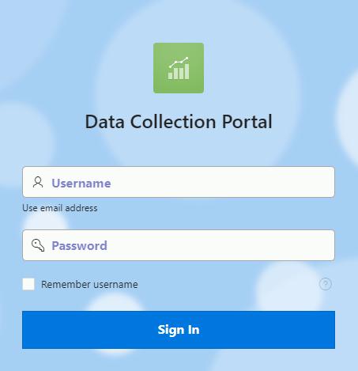

How do I submit a Project?
These steps assume you have followed the “How do I access the portal?” instructions above and your assigned role within the portal is “Agency IT Lead”. If you need a role assignment change, please reach out to cot.capitalitprojects@ky.gov.

- Click on “Project Intake”.

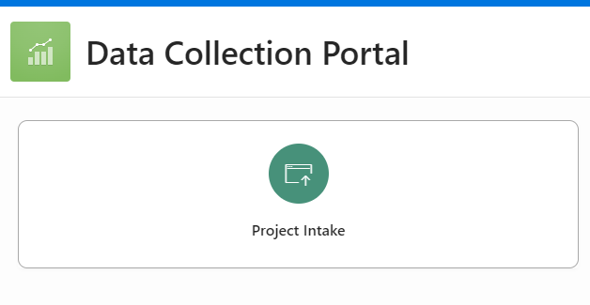

- Click “Capital Projects”.

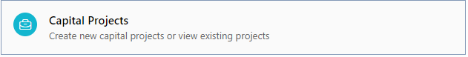

- Click “+ Project”, located near the top-right corner.

- Populate the Project Intake form.
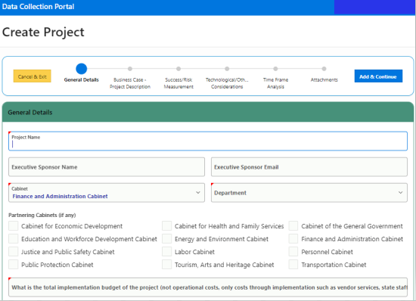

Things to remember while populating the Project Details form:

    - All fields are required.
    - Click Add & Continue after completing the “General details page”.
    - An outline of steps will appear at the top-right corner of the screen.

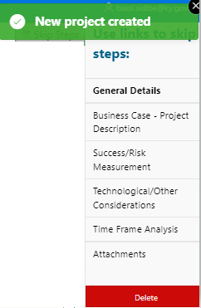

  - Complete the remaining sections for the project.
    - Business Case - Project Description
    - Success/Risk Measurement
    - Technological/Other Considerations
    - Time Frame Analysis
    - Attachments

Once you enter all the required information, click the save green button then the arrow to proceed.

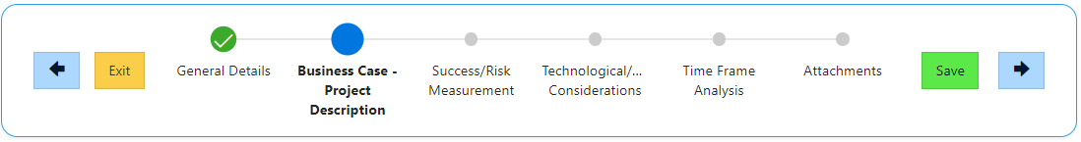

The two documents listed below are required.
- The Total Cost of Ownership (TCO) form
- A copy of the project submittal (SYP-P2) completed in the Capital Planning System
You can add them by clicking the button. You will be required to select which document you are uploading.

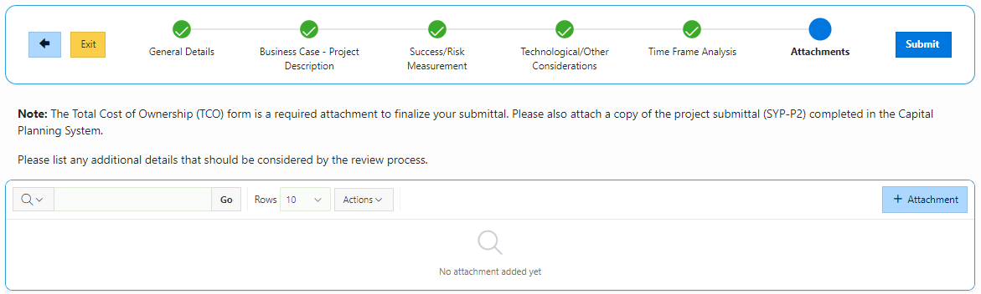

- Once you have completed all the required steps, click the submit.

Contact Us

Commonwealth Service Desk
- (502) 564-7576
- CommonwealthServiceDesk@ky.gov

Division of Governance and Strategy
Enterprise Standards Branch
- 500 Mero Street Frankfort, KY 40601
- Debra Weber, Division Director
- Bassi Sidibe, Enterprise Standards Branch Mgr.
- Chrissy Gibson, Portal Admin

Commonwealth of Technology Website
- https://technology.ky.gov/Pages/index.aspx

Capital IT Project Planning Webpage
- Capital IT Projects - Commonwealth Office of Technology (Kentucky)
- Email: cot.capitalitprojects@ky.gov

